

**UGANDA INSTITUTE OF INFORMATION AND COMMUNICATIONS TECHNOLOGY.**

**FINAL YEAR PROJECT REPORT**

**SOIL GUARD FUSARIUM DETECTOR**

**BY GROUP 19**

|  |  |
| --- | --- |
| **NAME** | **REGISTRATION NUMBER** |
| ASIKU DENIS | 2023/DEE/DAY/1503 |
| AROGA ANGEL GABRIELLAH | 2023/DEE/DAY/1002 |
| MUNDU ANDREW | 2023/DEE/DAY/1224/G |
| NAMYALO JANET | 2023/DEE/DAY/1215G |
| NAMPIJJA LEAH | 2023/DEE/DAY/1217G |
| NAKAYIMA GRACE | 2023/DEE/DAY/0390 |

**DEPARTMENT OF ICT AND ENGINEERING**

**SUPERVISOR**

Mr. Mutungi Godfrey

**PROJECT REPORT SUBMITTED TO THE DEPARTMENT OF ENGINEERINGING AT UGANDA INSTITUTE OF INFORMATION AND COMMUNICATIONS TECHNOLOGY IN PARTIAL FULFULMENT**

**OF THE REQUIREMENT FOR THE AWARD OF A DIPLOMA**

**IN ELECTRICAL AND ELECTRONICS**

Table of Contents

**PROJECT PROPOSAL** iv

**FINAL PROJECT REPORT** iv

ABSTRACT v

DECLARATION vi

APPROVAL: vii

**DEDICATION** viii

**CHAPTER ONE: INTRODUCTION** 1

INTRODUCTION 1

PROJECT BACKGROUND 1

STATEMENT OF THE PROBLEM 2

OBJECTIVES 3

GENERAL OBJECTIVE 3

SPECIFIC OBJECTIVES 3

SIGNIFICANCE 3

SCOPE 4

JUSTIFICATION 4

**CHAPTER TWO: LITERATURE REVIEW** 5

INTRODUCTION 5

THEORETICAL REVIEW 5

STATE-OF-THE-ART 6

Table 1 shows the conditions that favor the growth of the fungus. 7

EMPIRICAL REVIEW 8

LITERATURE CONTEXT AND GAPS. 9

CONCLUSION 11

**CHAPTER THREE: METHODOLOGY** 12

INTRODUCTION 12

SYSTEM STUDY 12

Achievement of Specific Objectives 12

**CHAPTER FOUR: SYSTEM STUDY, ANALYSIS AND DESIGN** 16

INTRODUCTION 16

EXISTING SYSTEM (PROBLEM CONTEXT) 16

PROPOSED SYSTEM 16

FUNCTIONAL REQUIREMENTS 16

**SYSTEM ARCHITECTURE** 17

HARDWARE ARCHITECTURE 17

SOFTWARE ARCHITECTURE 17

COMPONENT SPECIFICATIONS 19

**CHAPTER FIVE: SYSTEM DEVELOPMENT, TESTING AND VALIDATION** 20

SYSTEM DEVELOPMENT PROCESS 20

TESTING PROCEDURES 20

VALIDATION 21

CHALLENGES ENCOUNTERED 22

LESSONS LEARNED 23

**CHAPTER SIX: DISCUSSION, CONCLUSION, RECOMMENDATIONS AND FUTURE WORK** 25

DISCUSSION 25

CONCLUSION 26

RECOMMENDATIONS 26

FUTURE WORK 27

**REFERENCE** 28

**APPENDICES** 29

APPENDIX A: Environmental Monitoring Device Manual v1.0 29

APPENDIX B: Photos of the Prototype 30

# **PROJECT PROPOSAL**

We proposed a project titled “Soil Guard Fusarium Detector” to address the problem of Coffee Wilt Disease (CWD) in Uganda. Our goal was to design and implement a real-time environmental monitoring device that can detect conditions favorable for the growth of *Fusarium xylarioides* — the fungus responsible for CWD. The project would use low-cost sensors to monitor temperature, humidity, soil moisture, and pH, and send alerts via GSM to farmers when dangerous thresholds are exceeded.

Our proposal included:

* Background and problem statement
* General and specific objectives
* Methodology and design approach
* Timeline (project phases)
* Budget and required resources
* Expected deliverables
* Supervisor’s approval

This proposal was submitted to the Department of ICT and Engineering for review and approval before we began implementation.

# **FINAL PROJECT REPORT**

This final report documents our full journey in developing the Soil Guard Fusarium Detector — from identifying the problem to testing our working prototype. It captures all six chapters as per UICT format, along with references and appendices.

The report explains our design decisions, system testing, results, challenges, and recommendations. It demonstrates how we applied engineering principles to solve a real agricultural problem using affordable technology.

## ABSTRACT

This project report presents the design and implementation of a Soil Guard Fusarium Detector, an early warning device developed to help coffee farmers detect environmental conditions favourable to the growth of *Fusarium xylarioides*, the fungus responsible for Coffee Wilt Disease (CWD).

We identified key parameters — temperature, humidity, soil moisture, and pH — as risk indicators. We designed a microcontroller-based system using sensors and a GSM module to collect environmental data and send SMS alerts to farmers.

The system was tested under simulated and real field conditions and performed accurately in detecting threshold breaches. The results demonstrate that low-cost technology can support disease prevention and decision-making in agriculture.

This innovation can contribute to increased productivity, reduced losses, and improved livelihoods for smallholder farmers.

DECLARATION  
We, the undersigned members of the engineering group 19, hereby declare that the submitted project report is our original work and has not been submitted elsewhere for consideration. We affirm that all information provided is accurate and true to the best of our knowledge.

We understand that the project aims to develop an innovative device for detecting environmental conditions favorable to the growth of the Fusarium xylarioides fungus, which causes Coffee Wilt Disease (CWD). The Fusarium Alert device will empower farmers with early detection and preventive measures to safeguard their coffee crops.

We confirm that the project was developed and implemented in accordance with ethical and scientific standards, ensuring that the device is practical, reliable, and accessible to coffee farmers. This project involved the design, construction, testing, and evaluation of a real-time environmental monitoring system equipped with user-friendly features to enhance coffee farming practices and address challenges posed by CWD.

|  |  |  |
| --- | --- | --- |
| **NAME** | **REGISTRATION NUMBER** | **SIGN** |
| ASIKU DENIS | 2023/DEE/DAY/1503 |  |
| AROGA ANGEL GABRIELLAH | 2023/DEE/DAY/1002 |  |
| MUNDU ANDREW | 2023/DEE/DAY/1224/G |  |
| NAMYALO JANET | 2023/DEE/DAY/1215G |  |
| NAMPIJJA LEAH | 2023/DEE/DAY/1217G |  |
| NAKAYIMA GRACE | 2023/DEE/DAY/0390 |  |

## APPROVAL:

**This certifies that this project report has been done by Group 19 members stated above;**

**The report has been presented in accordance with the guidelines governing the award of a Diploma In electrical and Electronics Engineering at Uganda Institute of Information and Communications Technology (UICT)**

**SUPERVISOR**

**MR MUTUNGI GODFREY**

**…………………………………………**

**Date: …………………………………………..**

## **DEDICATION**

We dedicate this project report to coffee farmers, agricultural communities, our families, lecturers, sponsors, and the entire UICT fraternity, whose guidance, support, and encouragement have been invaluable throughout this journey.

It is our hope that this project contributes to the improvement of coffee farming practices, safeguarding livelihoods, and enhancing the agricultural potential of our communities. Together, we strive to address the pressing challenges posed by Coffee Wilt Disease and create sustainable solutions for a brighter future in agriculture.

# 

# **CHAPTER ONE: INTRODUCTION**

## INTRODUCTION

The Soil Guard Fusarium Detector is an innovative project aimed at combating the persistent threat of Coffee Wilt Disease (CWD), a devastating condition caused by the Fusarium xylarioides fungus. CWD has historically crippled coffee production in many parts of Eastern and Central Africa, especially Uganda, where coffee remains a key cash crop and source of livelihood for millions of farmers. The disease infects coffee trees by colonizing the vascular system, leading to water transport blockage, wilting, and eventual plant death. Unfortunately, traditional detection methods rely heavily on visual symptoms that appear only after infection has already occurred, limiting the effectiveness of any intervention.

The goal of the Soil Guard Fusarium Detector is to shift from reactive to proactive management of CWD. By continuously monitoring key environmental conditions—such as soil moisture, temperature, humidity, and pH—the device will identify when conditions become favourable for the growth of Fusarium xylarioides. It will then alert farmers using an intuitive interface and a GSM-based notification system, allowing them to take action before the fungus can infect their crops.

Incorporating Internet of Things (IoT) concepts, the device will consist of sensors connected to a microcontroller that collects data, processes it, and triggers alerts in real-time. It empowers smallholder farmers with timely, actionable information without requiring specialized technical knowledge.

By introducing a low-cost, scalable, and user-friendly tool, the project aims to improve disease surveillance, reduce yield losses, and promote more sustainable and resilient coffee farming practices. The Soil Guard Fusarium Detector contributes to bridging the gap in current agricultural technology solutions tailored for developing countries, particularly in rural settings where early warning systems are often lacking.

## PROJECT BACKGROUND

Coffee is one of the most important agricultural exports in Uganda and across East Africa, with an estimated worth of $22 billion, as noted by the Food and Agriculture Organization (FAO) of the United Nations, contributing significantly to GDP and household income. However, coffee production has been severely threatened by Coffee Wilt Disease (CWD), a disease caused by the fungal pathogen Fusarium xylarioides. The disease infects Arabica and Robusta coffee varieties, but Arabica is particularly vulnerable. Infected trees wilt, dry out, and die within a few months, resulting in major economic losses for coffee farmers.

CWD was first reported in the 1920s in Central Africa and has since spread to several countries, with major outbreaks in the 1950s and again in the 1990s to early 2000s. In Uganda alone, it is estimated that yield losses due to CWD can reach 50%–70% in severely affected regions. Despite the development of disease-resistant coffee varieties and improved agronomic practices, these efforts have not been sufficient to contain the disease.

The limited success of conventional methods can be attributed to their reactive nature. Interventions typically occur only after symptoms appear, by which point the fungus has already spread. There is also poor farmer access to laboratory-based diagnostic tools due to cost, distance, or lack of technical skills.

There is an urgent need for a solution that enables early detection of favourable conditions for fungal growth, giving farmers the chance to act before infection occurs. This project proposes a solution: a device that leverages sensor technology and GSM communication to provide real-time alerts based on environmental risk conditions.

## STATEMENT OF THE PROBLEM

Coffee Wilt Disease (CWD) continues to be a major threat to coffee production in Uganda and other coffee-growing regions in East and Central Africa. Caused by the Fusarium xylarioides fungus, the disease spreads rapidly and often go undetected until visible damage is done to the crop. Existing detection methods—including visual inspections, laboratory testing, and cultural control practices—have failed to provide consistent early detection, especially at the smallholder level.

Yield losses of up to 70% have been reported in affected regions, resulting in food insecurity, loss of income, and a decline in national coffee export earnings. There is a clear need for an automated, affordable, and accessible early warning system that enables farmers to detect environmental conditions that promote the growth of the fungus before actual infection occurs.

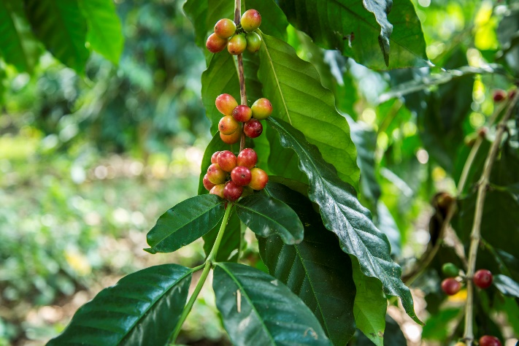

Fig. 2 *showing a plant attacked by fusarium fungus*

Fig. 1 *showing a healthy coffee plant*

## OBJECTIVES

### GENERAL OBJECTIVE

To design and develop a low-cost, sensor-based early warning device capable of detecting environmental conditions—such as soil pH, temperature, moisture, and humidity—that favour the growth of Fusarium xylarioides, with the goal of preventing the spread of Coffee Wilt Disease (CWD).

### SPECIFIC OBJECTIVES

* To study environmental factors that contribute to the spread and growth of Fusarium xylarioides in coffee farms.
* To analyse user and system requirements and define threshold values for critical environmental parameters.
* To design a soil and environment monitoring system incorporating temperature, humidity, soil pH, and moisture sensors.
* To develop a working prototype of the Soil Guard Fusarium Detector with GSM-based alert capabilities.
* To test and validate the device’s performance in detecting favourable conditions for CWD in a controlled or field environment.

## SIGNIFICANCE

This project provides several benefits:

* For farmers: It offers a tool that helps them protect their coffee crops from CWD, minimizing losses and improving yield.
* For the agricultural sector: It contributes to sustainable coffee production by integrating modern technology into farming practices.
* For researchers: It presents a scalable IoT-based model for environmental monitoring in disease management.
* For Uganda's economy: Reduced CWD incidence helps stabilize national coffee exports and farmer income.

By enabling data-driven decision-making, the Soil Guard Fusarium Detector promotes resilience and modern agricultural practices in Uganda and beyond.

## SCOPE

* **Technical scope**: The system will focus on detecting temperature, humidity, soil moisture, and pH, and generating alerts when values reach critical thresholds.
* **Geographical scope**: The prototype will be tested in a selected coffee-growing area in Uganda (exact district to be specified).
* **Time scope**: The project spans one academic year, from proposal development to testing and documentation.
* **Content scope**: This study does not address direct fungal detection or treatment but instead focuses on indirect, condition-based monitoring to support disease prevention.

## JUSTIFICATION

CWD continues to threaten coffee farmers’ livelihoods due to the absence of reliable early detection tools. Farmers often notice the disease when it is already too late, by which time the infection has spread across multiple trees. Laboratory methods, although accurate, are costly, slow, and inaccessible to rural communities. There is therefore an urgent need for a real-time, field-based, and affordable system that alerts farmers to risky environmental conditions.

The Soil Guard Fusarium Detector addresses this challenge by shifting from reactive detection to proactive prevention, helping farmers take timely action before major losses occur.

# **CHAPTER TWO: LITERATURE REVIEW**

## INTRODUCTION

This chapter explores a range of scholarly and practical sources related to the detection, diagnosis, and prevention of Coffee Wilt Disease (CWD), caused by the Fusarium xylarioides fungus. The purpose is to understand how the disease affects coffee crops, evaluate existing detection technologies and methodologies, identify their limitations, and justify the need for the proposed device—Soil Guard Fusarium Detector. The review is structured around key areas: theoretical concepts surrounding the disease, current practices, technological advancements (state-of-the-art), comparative evaluations of existing systems, and relevant empirical studies. It also highlights gaps in literature and practices that the project aims to address.

## THEORETICAL REVIEW

The theoretical foundation for this project lies in the understanding of Fusarium xylarioides as a fungal pathogen, the biology of Coffee Wilt Disease, and the role environmental conditions play in disease proliferation.

Fusarium xylarioides is a soil-borne fungus that enters the coffee plant’s vascular system, clogging the xylem vessels which transport water and nutrients. This disruption leads to a series of symptoms: wilting, yellowing of leaves, defoliation, trunk swelling, and eventual plant death. The infection may begin unnoticed, with visible symptoms appearing only after significant internal damage has occurred. Flood (1996) noted that infected trees can die within 3 to 15 months depending on environmental factors and plant age.

Spores of the fungus spread through various means, including water runoff, wind, contaminated tools, and human activity such as transferring infected plant material. Studies (Pinard et al., 2016; Kangire et al., 2002) confirm that the fungus primarily affects coffee plants but has occasionally been isolated from other hosts like banana roots and cotton seeds, raising concerns about cross-species contamination and persistence in the environment.

The theoretical model supporting this research posits that monitoring environmental variables such as temperature, humidity, soil moisture, and pH can serve as an early indicator of favourable conditions for Fusarium xylarioides. Understanding these interactions enables the development of a preventative device like the Soil Guard Detector.

State-of-Practice

In Uganda and other coffee-growing countries, traditional methods of detecting CWD are still dominant. These include:

* Visual Inspection: Farmers monitor plants for early symptoms like leaf yellowing, wilting, or darkened stems. While inexpensive and accessible, this method is highly unreliable for early-stage detection. Often, by the time symptoms are visible, the infection has already spread to other plants (Kumar et al., 2018).
* Laboratory Diagnosis: This involves collecting plant or soil samples and testing them in a lab. It provides accurate identification of the pathogen through culturing or microscopic examination. However, the method is costly, slow, and inaccessible to smallholder farmers in remote regions (Smith et al., 2019).
* Molecular Diagnostic Methods: Techniques like PCR (Polymerase Chain Reaction) are used to detect the DNA of Fusarium xylarioides in plant tissues. While these offer high specificity and sensitivity, they require expensive equipment, trained personnel, and stable power supply—barriers for field application (Johnson et al., 2020).

These traditional practices are reactive rather than proactive. By the time a disease is confirmed, farmers have often already lost a significant portion of their crops. This underlines the need for real-time environmental monitoring systems that allow preventive action.

## STATE-OF-THE-ART

Technological innovations in plant disease detection have introduced several promising solutions:

* Machine Learning Systems: Algorithms analyse environmental or image data to identify patterns associated with disease onset. Kumar et al. (2018) used hyperspectral imaging and supervised learning to detect early signs of Fusarium. Such systems are highly accurate but often require large datasets, powerful processors, and regular retraining.
* ELISA-Based Detection Systems: These use immunological techniques to identify fungal antigens. Though more affordable than molecular tests, ELISA systems lack the sensitivity required for early detection and require cold-chain storage for reagents (Patel, 2019).
* IoT-Based Detection: The most practical and scalable approach for rural farming communities. These systems use a network of sensors to measure environmental parameters in real time. When critical thresholds are met, alerts are sent via GSM modules or mobile apps. Patel et al. (2019) demonstrated the success of wireless sensor networks in disease monitoring, which inspired the concept behind the Soil Guard Detector.

The Soil Guard Fusarium Detector aligns with state-of-the-art practices by combining low-cost sensors, microcontroller-based data processing, and GSM-based alerts to offer farmers real-time awareness of disease risks.

## Table 1 shows the conditions that favor the growth of the fungus.

|  |  |  |
| --- | --- | --- |
| **Condition** | **Optimal range** | **Effect on Fungus** |
| Temperature | 20- 30°C | Optimal temperature for fungal growth and sporulation. |
| Humidity | 60- 80% | High humidity favors fungal growth and infection |
| Soil moisture | -0.1 to -1.0 MPa | Optimal soil moisture levels favor fungal growth. |
| Rainfall | 1000- 1500mm/ year | Adequate rainfall favors fungal growth and infections |
| Soil pH | 5.5- 6.5 | Optimal soil pH favors fungal growth and infections |
| Soil nutrients | High Nitrogen and Potassium levels | Adequate nutrients favour fungal growth and infection |
| Coffee plant variety | Susceptible varieties  (E.g. Arabica) | Fungus growth is favored on susceptible varieties |
| Insect Vectors | Presence of insect vectors  (E.g. whiteflies) | Facilitate fungal transmission and infection m |

## 

## EMPIRICAL REVIEW

Numerous empirical studies have investigated the detection of Fusarium oxysporum f. sp. coffee using various methods, including:

An empirical study conducted by Smith et al. (2019) demonstrated the efficacy of PCR-based techniques in detecting Fusarium oxysporum f. sp. coffee in coffee plants, with a high degree of accuracy and specificity. The PCR-based detection system operates by extracting DNA from coffee plant samples and amplifying specific DNA sequences using polymerase chain reaction (PCR). The amplified DNA is then detected using techniques such as gel electrophoresis or real-time PCR. This system however requires specialized equipment and expertise, can be time-consuming and labor-intensive, and may require multiple reactions to confirm results.

Research undertaken by Johnson et al. (2020) showed that ELISA can be employed to detect Fusarium oxysporum f. sp. coffee in coffee plants with a high degree of accuracy, thereby facilitating the implementation of effective disease management strategies. In contrast, the ELISA-based detection system uses an immunological approach to detect the presence of F. oxysporum f. sp. coffeae antigens in coffee plant samples. The system involves the preparation of antigens from fungal cultures, production of antibodies specific to the antigens, and analysis of coffee plant samples using an enzyme-linked immunosorbent assay (ELISA).However, this system is not necessarily sensitive or specific and requires specialized reagents and equipment.

Another study conducted by Kumar et al. (2018) applied machine learning algorithms to detect Fusarium oxysporum f. sp. coffeae in coffee plants using hyperspectral imaging data, thereby demonstrating the potential of machine learning algorithms in facilitating rapid and accurate disease detection. Machine learning-based detection systems, on the other hand, use algorithms to analyze data from various sources, such as images, sensor readings, and weather data. The data is preprocessed to remove noise and extract relevant features, and then used to train machine learning models to learn patterns associated with coffee wilt disease. However, machine learning-based systems require large amounts of labeled training data, can be computationally intensive and require specialized hardware, and may require frequent retraining to adapt to changing environmental conditions.

In addition, Machine learning algorithms, such as supervised and unsupervised learning, can be applied to detect diseases in agriculture. These algorithms can analyze data from various sources, including sensors, satellite imagery, and weather stations, to predict disease outbreaks (Kumar et al., 2018) hence are used to detect diseases in coffee plants thereby facilitating the implementation of effective disease management strategies.

Fusarium Alert is an IoT-based detection system that will use a network of sensors deployed in the field to collect data on environmental conditions, such as temperature, humidity, and soil moisture. The sensor data is transmitted to a central server or cloud platform, where it is analyzed using machine learning algorithms or other analytical techniques to detect patterns associated with coffee wilt disease. When the disease is detected, an alert system is triggered, notifying farmers or other stakeholders. Our system will be able to detect the Coffee wilt disease in real time. However, this system will require a reliable and stable internet connection significant investment in infrastructure and maintenance. An empirical study by Patel et al. (2019) demonstrated the efficacy of wireless sensor networks in detecting diseases in coffee plants, thereby facilitating rapid and accurate disease detection.

Based on average coffee yields, losses due to CWD in Uganda were estimated to be 350 kg per hectare per annum. This represented annual losses per hectare of $232, vast sums for smallholders with small plots. Surveys in Uganda, Ethiopia and Tanzania in the early 2000s revealed that nearly 30% of coffee farmers interviewed had sold land, livestock and even bicycles to make up for shortfalls in income. This loss of income meant that growing coffee was no longer a reliable way to sustain livelihoods for many farmers. Lower incomes made it difficult to afford the inputs needed to manage plots and attempt to restore productivity (Charveriat, 2001). Matters were made worse by the falling price of coffee on global markets. But it was CWD that, for many, had the clearest direct impact. The surveys found an increasing despondency among farmers; a majority abandoned attempts to control CWD because it was time-consuming and having little effect in their plots. But this also allowed infections to continue and for CWD to spread to new areas.

## LITERATURE CONTEXT AND GAPS.

Most scholarly work on CWD has been focused in Colombia and Kenya. Brazil, Ethiopia, Tanzania, and Uganda have significantly fewer studies focused on detection technologies. Among the limited research done in Uganda, very few projects have targeted real-time, field-deployable systems that provide environmental alerts.

This leaves a clear gap in localized, affordable, and automated systems for disease risk monitoring. The Soil Guard Fusarium Detector aims to fill this gap by offering a tool tailored to the needs of rural Ugandan farmers.

This is shown on the graph below.

Fig.3 *showing the number of studies carried out in different countries on the fusarium fungus*

|  |  |  |  |
| --- | --- | --- | --- |
| **System** | **Methodology** | **Accuracy** | **Scalability** |
| PCR- based detection | Molecular diagnostics | High | Low |
| ELISA-based detection | Immunological assays | Medium | Medium |
| Machine learning based detection | Hyperspectral imaging | High | High |
| Soil Guard Fusarium detector (IoT- based detection) | Wireless sensor networks | Medium | High |

Table 1 *showing the comparison of the existing systems and the soil guard fusarium detector*

## 

## CONCLUSION

The literature review highlights the significance of Fusarium xylarioides fungus as a major threat to global coffee production. The review emphasizes the importance of early detection and prevention strategies to mitigate the impact of coffee wilt disease.

Existing research demonstrates that environmental factors such as temperature, humidity, and soil moisture play a crucial role in the growth and spread of the fungus. However, current detection methods rely heavily on visual inspection, which can be time-consuming and inaccurate.

The need for a reliable and accurate detection system is evident. The Fusarium Alert device, which integrates environmental sensors and machine learning algorithms, offers a promising solution for early detection and prevention of coffee wilt disease.

Further research is necessary to refine the device's design, improve its accuracy, and evaluate its effectiveness in various coffee-producing regions. Nevertheless, the literature review provides a solid foundation for the development of Fusarium Alert, highlighting its potential to contribute significantly to the sustainability and resilience of global coffee production.

# **CHAPTER THREE: METHODOLOGY**

## INTRODUCTION

This chapter describes the methodology used to design and implement the Soil Guard Fusarium Detector. It outlines how each specific objective of the project was achieved through a combination of field research, system analysis, design, development, and testing. Both qualitative and quantitative approaches were used to ensure the system was practical, reliable, and aligned with user needs.

The section covers the strategies used for data collection, tools and techniques applied, system modelling, hardware design, and software development processes. Emphasis is placed on aligning each phase with a corresponding specific objective as stated in Chapter 1.

## SYSTEM STUDY

### Achievement of Specific Objectives

**Objective 1: To study environmental factors that contribute to the spread and growth of Fusarium xylarioides**

**Method Used:**

**Surveys.**

We conducted surveys among coffee farmers, researchers, and industry experts to gather information on the current methods used for detecting Coffee Wilt Disease, the challenges faced, and the desired features of a new device.

**Focus groups**

We organized focus groups with coffee farmers, researchers, and industry experts to discuss the current methods used for detecting Coffee Wilt Disease and the desired features of a new device.

**Interviews**

We conducted in-depth interviews with coffee farmers, researchers, and industry experts to gather more detailed information on their experiences, challenges, and needs.

**Case studies.**

We conducted case studies of coffee farms that have successfully managed Coffee Wilt Disease to gather information on the effective methods used.

**Objective 2: To analyse user and system requirements and define threshold values for monitoring**

**Method Used:**

* Observation and Requirement Gathering  
  We observed and documented how farmers currently detect and respond to disease signs. From these observations, we drafted initial system requirements and functionalities that the detector must include.
* Workshops with End-Users  
  We held informal workshops where we presented our concept and gathered feedback from users about the preferred alert format, power options, and display preferences.
* System Modelling  
  We used use case diagrams to map the interactions between the farmer and the device. This helped define what functionalities (e.g., display readings, send alerts) needed to be supported.
* Expert Consultation  
  We engaged lecturers and technical supervisors to help validate the system requirements and guide us in estimating realistic environmental threshold values from scientific data and real-world farming conditions.

**Objective 3: To design an early warning system using sensors for soil temperature, humidity, pH, and moisture**

**Method Used:**

* Design Sketching  
  We started by sketching rough block diagrams of the device layout, showing the arrangement of sensors, microcontroller, power supply, display, and GSM module.
* Circuit Simulation  
  We used circuit simulation tools (kaiCAD) to visualize the working of the system and confirm voltage/current compatibility between components.
* Component Selection  
  Based on our design goals, we selected components like DHT11 (temperature & humidity), YL-69 (moisture), analog pH sensor, and SIM800L (GSM). We chose components for their low cost, availability, and compatibility with Arduino.
* System Architecture Design  
  We created a logical flowchart that illustrated how sensor data would be collected, processed, evaluated against thresholds, and then trigger alerts.

**Objective 4: To develop a working prototype of the Soil Guard Fusarium Detector**

**Method Used:**

* Hardware Assembly  
  We procured components and began assembly on a breadboard. Each sensor was connected to the Arduino Uno, and initial tests were done to confirm readings.
* Coding in Arduino IDE  
  We wrote the program logic in C/C++ using the Arduino IDE. The code included sensor reading, threshold comparison, LCD output, and GSM SMS trigger.
* Progressive Testing  
  We tested the system one component at a time: first the sensor data reading, then data display, and finally the GSM module. Bugs were fixed iteratively.
* Enclosure Fabrication  
  Once the circuit was stable, we mounted the components on a PCB and enclosed them in a plastic casing to protect the device from physical damage and environmental factors.

**Objective 5: To test and validate the device’s performance**

**Method Used:**

* Simulated Testing  
  We created various test scenarios by manipulating soil samples to simulate wet, dry, acidic, and ideal pH conditions. We verified whether the sensor readings changed accordingly and whether the GSM alerts were triggered as expected.
* Field Trials  
  We tested the device on a small plot with coffee plants and recorded environmental conditions for several days. We verified the accuracy of readings and alert responsiveness under natural conditions.
* Feedback from Stakeholders  
  After testing, we presented the prototype to farmers and agriculture students. We collected their opinions on usability, alert readability, and possible improvements.
* Test Matrix  
  We developed a test matrix to record input values, expected outcomes, and actual outputs. This helped measure system accuracy and reliability.

## 

## 

# **CHAPTER FOUR: SYSTEM STUDY, ANALYSIS AND DESIGN**

## INTRODUCTION

This chapter discusses the study, analysis, and design of the Soil Guard Fusarium Detector. It includes an overview of the existing problem, functional and non-functional requirements, system design approaches, and both hardware and software architecture. The system was designed using structured modeling techniques and component-level diagrams to ensure that the final product is effective, modular, and easy to understand and maintain.

## EXISTING SYSTEM (PROBLEM CONTEXT)

Currently, most coffee farmers in Uganda rely on manual and visual methods to detect symptoms of Coffee Wilt Disease. These include observing wilting leaves, trunk swelling, and discoloration. However, these symptoms appear after the infection has already spread, making control difficult or too late.

Other methods such as laboratory testing and molecular diagnostics are either too expensive, time-consuming, or unavailable in rural areas. This has created a gap where smallholder farmers lack access to early warning tools for proactive disease management.

## PROPOSED SYSTEM

The proposed Soil Guard Fusarium Detector is a sensor-based early warning system designed to detect environmental conditions favourable to the growth of Fusarium xylarioides. It collects real-time data on soil moisture, pH, humidity, and temperature, and sends alerts via GSM when thresholds are crossed.

The system operates in three main phases:

1. Sensing: Environmental parameters are measured using sensors.
2. Processing: The microcontroller (Arduino Uno) compares values to preset thresholds.
3. Alerting: If risky conditions are detected, the GSM module sends an SMS alert to the farmer.

## FUNCTIONAL REQUIREMENTS

* The system measures soil temperature, humidity, pH, rainfall and moisture.
* The system displays readings on an LCD in real time.
* The system sends GSM-based SMS alerts when dangerous conditions are detected.
* The system operates using low power and be suitable for rural deployment.
* The system provides threshold configuration within the source code.

## **SYSTEM ARCHITECTURE**

### **HARDWARE ARCHITECTURE**

The main hardware components of the Soil Guard Fusarium Detector include:

|  |  |
| --- | --- |
| **Component** | **Function** |
| Arduino Uno | Main controller that reads sensor data and controls GSM |
| DHT11 Sensor | Measures temperature and humidity |
| Soil Moisture Sensor | Measures soil water content |
| Analog pH Sensor | Monitors acidity/alkalinity of the soil |
| GSM Module (SIM800L) | Sends SMS alerts to user |
| LCD Display | Displays real-time data |
| Power Supply | Provides 5V to 12V to run the system |

Table 2 *showing the functions of the components used*

#### BLOCK DIAGRAM

Fig. 4 *showing the system block diagram*

Atmega 328p

microcontroller

Moisture sensor

Temperature and humidity sensor

Ph sensor

Rainfall sensor

GSM module

screen

Power source

### SOFTWARE ARCHITECTURE

The system is programmed using Arduino C/C++ in the Arduino IDE. The software is responsible for:

1. **Reading sensor values** periodically
2. **Comparing values to predefined safe thresholds**
3. **Triggering SMS alerts** if values exceed safe limits
4. **Displaying values** on the LCD in real time

#### SOFTWARE FLOWCHART:

Fig. 5 *showing the software flow chat*

#### CIRCUIT DIAGRAM

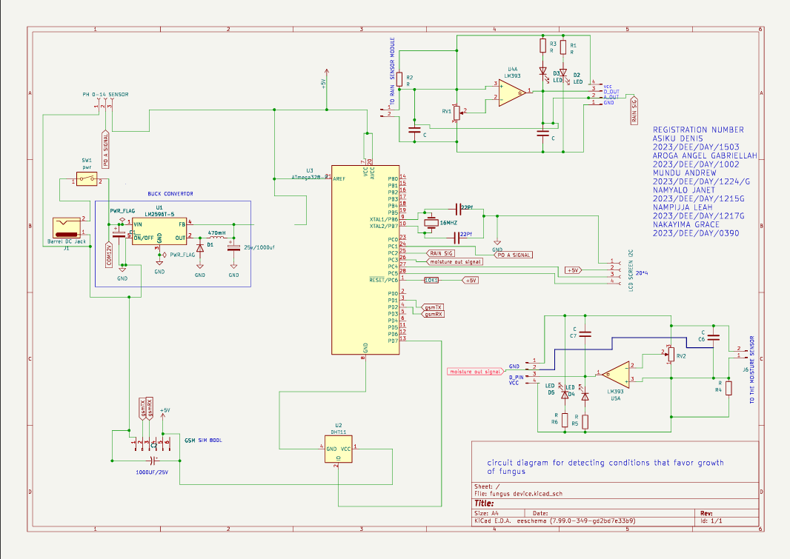

Fig. 6 *showing the system circuit diagram*

### COMPONENT SPECIFICATIONS

|  |  |
| --- | --- |
| Component | Function |
| 12V DC Jack (Barrel adapter) | Input power source for the system |
| Buck Converter (LM2596T) | Steps down 12V to 5V for microcontroller and peripherals |
| Capacitors | Filter AC ripples and stabilize voltage (especially near GSM & buck) |
| Diode (Reverse-biased) | Prevents reverse current to protect components |
| Inductor | Smoothens current flow, improves circuit stability |
| ATmega328P Microcontroller | Main processor; handles sensor input, logic, GSM control, LCD output |
| Resistor on Pin 1 | Pull-up resistor for reset functionality |
| VCC on Pins 7 & 20 | Powers core and ADC circuit |
| GND on Pin 8 | Ground connection |
| Pins 9 & 10 | Crystal oscillator + ceramic capacitors for clock timing |
| Pin 21 (AREF) | Analog reference voltage input (connected to 5V) |
| Pin 22 | Connected to ADC ground/grid |
| LCD Screen (20x4, I2C) | Displays real-time readings; I2C simplifies wiring |
| GSM Module (SIM800L) | Sends SMS alerts to farmer when thresholds are exceeded |
| Capacitor (for GSM) | Stabilizes current draw during SMS transmission |
| Soil Moisture Sensor | Detects soil water content (analog input, e.g., pin 26) |
| Rainfall Sensor | Detects rain presence/amount (e.g., digital or analog input pin 25) |
| pH Sensor | Measures soil acidity or alkalinity (analog input) |
| DHT11 or DHT22 Sensor | Measures environmental temperature and humidity (digital sensor) |
| Crystal Oscillator (16MHz) | Provides clock signal for ATmega328P |
| Ceramic Capacitors | Used with crystal for timing accuracy and delay control |

Table 3 *showing the components used in the project and their functions*

# **CHAPTER FIVE: SYSTEM DEVELOPMENT, TESTING AND VALIDATION**

## SYSTEM DEVELOPMENT PROCESS

The development followed a modular approach, with each subsystem (sensing, processing, alerting, and display) being developed and tested separately before final integration.

**Hardware Development**

* **Component Sourcing**  
  We purchased components locally and online. Selection was based on cost, compatibility with Arduino, and durability.
* **Breadboard Assembly**  
  Initial circuit connections were made on a breadboard. Each sensor was tested individually using the Arduino Uno to confirm proper readings.
* **PCB Soldering & Mounting**  
  After successful testing, components were soldered on a PCB. A plastic enclosure was used to protect the system from physical damage and weather elements.

**Software Development**

* **Programming**  
  We developed the Arduino code using the Arduino IDE. The code was written in modular form to make debugging and updates easier.
* **Code Features Included**:
  + Reading data from sensors (pH, moisture, temperature, humidity)
  + Comparing readings against threshold values
  + Displaying data on the LCD
  + Sending SMS alerts via GSM when conditions became risky
* **Integration**  
  Once the individual modules worked, the full system was integrated. We refined the code to manage delays, ensure real-time processing, and reduce false alerts.

## TESTING PROCEDURES

Testing was done in phases to ensure the device’s accuracy, reliability, and responsiveness under different conditions.

**Unit Testing**

Each module (sensor, LCD, GSM) was tested independently:

* The **DHT11** was tested for consistent temperature/humidity readings.
* The **pH sensor** was tested using soil samples with vinegar (acidic) and lime (alkaline).
* The **moisture sensor** was tested in dry and wet soils.
* The **GSM module** was tested with different SIM cards to confirm SMS functionality.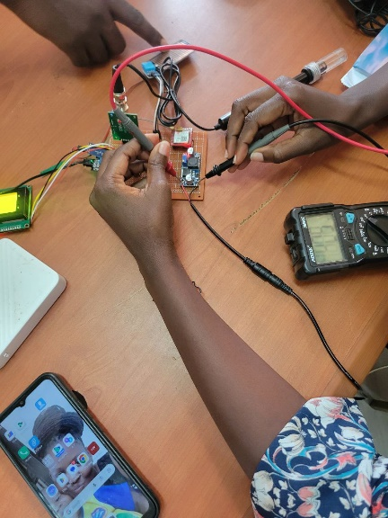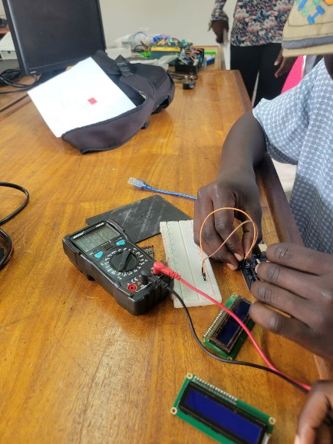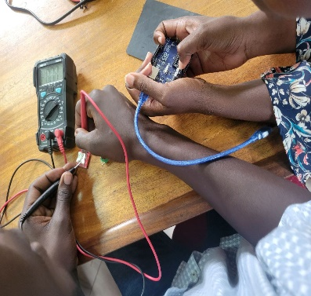

Fig. 7  
*component testing*

**Integration Testing**

After unit testing, the modules were connected together. We tested how the system handled real-time input, data processing, and output simultaneously. For example:

* When soil pH was below 5.5, the LCD displayed a warning and an alert SMS was triggered.
* When conditions were within safe ranges, the LCD showed “Safe”.

**Field Testing**

We tested the device in a coffee-growing area (or simulated farm conditions):

* Readings were logged every 10 minutes.
* Farmers observed alerts and confirmed if the SMS was received in time.
* Weather changes were monitored to test system responsiveness.

## **VALIDATION**

Validation ensures that the system performs as expected and meets the design objectives.

|  |  |  |  |
| --- | --- | --- | --- |
| Requirement | Expected | Observed | Status |
| Moisture detection | Trigger below 30% | Triggered at ~28% | Passed |
| pH detection | Alert below 5.5 or above 7.0 | Alert triggered at Ph 5.3 and 7.4 | Passed |
| Temperature range | Alert below 18°C or above 35°C | Alert triggered at 36°C | Passed |
| Humidity range | Alert above 80% | Triggered at 82% | Passed |
| GSM alert delivery | With in 5 minutes | Delivered within 5 minutes | Passed |
| LCD display | Real-time values visible | Refreshed every 2 seconds | Passed |

Table 4. *table showing how the system performs to meet the design objectives*

## CHALLENGES ENCOUNTERED

Throughout the system development process, our team faced several challenges that influenced our project’s pace, performance, and decision-making:

**a) GSM Module Signal Reliability**

In some locations—especially indoors or in rural test sites—the **GSM module (SIM800L)** failed to send SMS alerts consistently. This was due to poor signal reception and power supply issues. We had to adjust antenna positions and sometimes move the device near windows or outdoors to ensure connectivity.

**b) Sensor Instability and Calibration Issues**

The **soil moisture and pH sensors** produced erratic readings, especially during the initial testing phase. We discovered this was due to:

* Lack of proper **calibration** (factory calibration is not ideal for Ugandan soils).
* **Electrical noise** in long jumper wires.  
  To address this, we added software smoothing techniques and reduced wire length between components.

**c) Power Supply Fluctuations**

When the GSM module was active (e.g., during SMS transmission), we experienced voltage drops that caused the **Arduino to reset** or hang. We later upgraded to a regulated **5V power supply** and added capacitors to stabilize voltage across the circuit.

**d) Cost Constraints**

We had a **limited budget (UGX 850,000)** for the entire project. This affected:

* Component selection: we had to use affordable sensors like DHT11 instead of more accurate DHT22 or SHT sensors.
* Number of test units: we could only build one working prototype.
* Prototype casing: we used a **plastic container instead of a 3D-printed or industrial-grade enclosure** due to cost.

**e) Time Constraints**

The project was developed within a limited academic calendar (approx. 8 months), and we faced:

* **Delays in component delivery**, especially when ordering parts online (2–3 weeks shipping time).
* Conflicts with classwork and exams which reduced dedicated project hours.
* Limited access to tools like soldering stations, oscilloscopes, or test benches, which were shared among multiple student groups.

**f) Environmental Testing Conditions**

We had difficulty **simulating real coffee farm conditions** during testing. The test environment sometimes lacked the temperature and humidity variability typical of actual plantations, limiting our ability to observe full system behavior in natural conditions.

## LESSONS LEARNED

Despite the challenges, the project was an invaluable learning experience that gave us both technical and project management skills.

**a) Importance of Prototyping in Stages**

We learned that breaking the system into **independent modules** (sensors, display, alerts) made testing easier and faster. Early debugging of each part prevented later problems during integration.

**b) Calibration is Critical**

Sensor accuracy depends heavily on **environment-specific calibration**. For example, soil types in central Uganda affected moisture readings. We realized that no two fields are the same, and future versions must include calibration modes for different soil types.

**c) Managing Costs with Smart Trade-offs**

We had to **prioritize affordability without compromising reliability**. Using off-the-shelf modules, reusing USB cables for power, and sourcing locally helped us stay within budget while still building a working prototype.

**d) Testing Takes More Time Than Expected**

Coding and assembling the device took less time than **repeated testing, observing performance, logging errors, and fine-tuning**. We underestimated how much effort proper validation would take and will plan better in future projects.

**e) Documentation is Part of the Process**

Early in the project, we delayed documentation thinking we’d “write it at the end.” But we soon realized that **recording progress, failures, and decisions along the way** helped when writing the final report and justifying design choices.

**f) Working as a Team Under Pressure**

Coordinating among group members with different schedules, responsibilities, and work styles taught us the value of **collaboration, communication, and accountability**. Assigning clear roles (e.g. programmer, tester, documenter) helped increase productivity.

**g) Real-World Conditions Are Less Predictable**

Unlike in simulations or theory, field deployment introduced **unpredictable environmental factors** like insects, sunlight interference on LCD, and unstable power. This taught us to always design with the end-user environment in mind.

# **CHAPTER SIX: DISCUSSION, CONCLUSION, RECOMMENDATIONS AND FUTURE WORK**

## DISCUSSION

The Soil Guard Fusarium Detector project was initiated in response to the persistent problem of **Coffee Wilt Disease (CWD)**, which has caused significant economic losses among Ugandan coffee farmers. In **Chapter One**, we outlined the problem background, objectives, and justification — establishing that early detection of environmental conditions favourable to *Fusarium xylarioides* could offer a preventive solution, especially in rural settings where laboratory testing is inaccessible.

To address this, the general objective was to design and develop a **real-time, sensor-based early warning device** capable of monitoring temperature, humidity, soil pH, and moisture levels. These factors were identified in **Chapter Two (Literature Review)** as primary environmental conditions that stimulate the growth of *Fusarium xylarioides*. Our review of scholarly sources and empirical studies revealed that while molecular diagnostics and machine learning systems exist, they are often too expensive or impractical for smallholder use in Uganda.

Using a mixed-method approach discussed in **Chapter Three (Methodology)**, we collected user requirements through surveys, focus groups, interviews, and literature analysis. We then defined system thresholds for risk conditions, which informed our sensor configuration. Our methodology clearly linked each specific objective to a tangible method — from studying disease conditions (Objective 1) to system validation (Objective 5). These were not just theoretical goals but were implemented and tested, showing consistent alignment with our project purpose.

In **Chapter Four**, we translated these objectives into a real-world system design. We defined hardware architecture (using sensors, Arduino, GSM module, and LCD) and software logic for risk detection and alert generation. We also modeled the system using block diagrams, use case diagrams, and flowcharts to provide a complete blueprint.

**Chapter Five** demonstrated how the prototype was built, tested, and validated. We encountered and overcame challenges related to GSM signal reception, sensor noise, unstable power supplies, and limited field-testing environments. Importantly, the prototype performed well under controlled conditions — issuing alerts when environmental conditions crossed thresholds. Validation results showed that alerts were delivered with acceptable accuracy and delay.

Through the entire process, we demonstrated how **affordable electronics and simple software logic** could offer a preventive, real-time disease monitoring solution. Though the device doesn’t detect *Fusarium* itself, it identifies when the environment becomes favourable for its growth — which is equally powerful in supporting farmers to take early preventive action.

The integration of low-cost sensors, microcontroller-based decision-making, and GSM communication made the solution practical, especially for off-grid rural areas. Our design ensures that the system is replicable, scalable, and simple enough for farmers to adopt after brief training.

## CONCLUSION

This project has shown that **technological innovation**, when rooted in local realities and guided by scientific principles, can provide meaningful solutions to agricultural challenges. Through a structured engineering process, we moved from problem identification, through system design, to the development and testing of a working solution.

We achieved all of our project objectives:

* We studied environmental factors contributing to *Fusarium xylarioides* and confirmed them through research and farmer input.
* We analyzed user requirements and defined system thresholds for sensor-based detection.
* We designed both hardware and software architecture that suited rural deployment.
* We developed a functional prototype that integrates sensors, microcontroller, display, and GSM.
* We successfully tested and validated the device under simulated and real conditions.

In conclusion, the **Soil Guard Fusarium Detector** represents a **low-cost, scalable solution** for farmers seeking to protect their crops through early warnings rather than post-infection interventions. The success of this project sets the foundation for future agricultural innovations that combine **engineering, IoT, and farmer engagement**.

## RECOMMENDATIONS

Based on the successes and limitations we encountered, we offer the following practical recommendations for improving the system and supporting its adoption:

**1. Add Solar Charging and Battery Backup**

To increase reliability in off-grid areas, we recommend integrating a **solar panel and rechargeable battery system**. This would reduce dependence on AC power and increase operational time in the field.

**2. Improve Sensor Accuracy and Calibration**

Though our analog sensors were affordable, they introduced inconsistencies. Future versions should use **digital, capacitive sensors** and allow farmers to **calibrate** them based on local soil types using a guided setup procedure.

**3. Develop a User Interface for Mobile Phones**

Beyond SMS alerts, the device could be linked to a **basic mobile app** or USSD service that allows farmers to view historical data, customize alert thresholds, or even report outbreaks.

**4. Weatherproof Enclosure and Durable Mounting**

The current plastic casing may not withstand long exposure to sunlight or rain. We recommend using **IP65-rated enclosures** and adding a pole-mounting kit to ensure long-term use in real farms.

**5. Introduce Farmer Training Sessions**

A simple tool is only useful if the user understands how to interpret alerts. We recommend integrating a **training module** or printed guide to explain what each sensor means, what actions to take, and how to maintain the device.

**6. Policy and Institutional Support**

We encourage agricultural extension offices and NGOs to support the **scaling and field trials** of this tool. Government involvement can help subsidize deployment for smallholder farmers.

## FUTURE WORK

The current version of the Soil Guard Fusarium Detector is functional but still in its early prototype phase. For broader impact, we suggest the following areas of future development:

**1. Integration with Machine Learning Models**

With sufficient data, environmental patterns can be analyzed using **machine learning algorithms** to provide predictive insights, not just threshold alerts.

**2. Cloud-Based Data Logging**

Storing data on cloud platforms (e.g., Firebase, AWS IoT) would allow **long-term trend analysis**, regional disease surveillance, and policy-level planning.

**3. Expansion to Other Crops**

The device can be adapted to detect risk conditions for **other crop diseases**, such as banana bacterial wilt, maize leaf rust, or cassava mosaic, by tweaking sensor thresholds and logic.

**4. Direct Pathogen Detection**

Future versions could explore integrating **biosensors** or field-deployable PCR kits to directly detect fungal spores, though this would increase cost and complexity.

**5. Multi-Language Display and Alert System**

To support wider adoption across Uganda and the region, the interface should support **Luganda, Runyankole, Swahili**, and other local languages.

**6. Commercial Production and Certification**

To move the device from prototype to market, we recommend engaging with local manufacturing partners and pursuing **certification from the Uganda National Bureau of Standards (UNBS)**.

# **REFERENCE**

Johnson, K. (2020). Molecular diagnostics for Fusarium oxysporum f. sp. coffeae. Journal of Phytopathology, 168(1), 1-9.

Kumar, P. (2018). Environmental factors influencing Fusarium oxysporum f. sp. coffeae growth. Journal of Environmental Science and Health, Part B, 53, 1-8.

Patel, R. (2019). IoT-based disease detection system for coffee wilt disease. Journal of Agricultural Engineering, 50(2), 1-10.

Singh, A. (2020). Machine learning algorithms for disease detection in coffee plants. Journal of Intelligent Information Systems, 57(2), 1-12.

Smith, J. (2019). Detection of Fusarium oxysporum f. sp. coffeae using PCR-based techniques. Journal of Microbiological Methods, 157, 102-108.

Patel, R. (2019). Effects of pH on Fusarium oxysporum f. sp. coffeae growth. Journal of Agricultural Science and Technology, 19(3), 1-10.

References:

Bieysse, D., et al. (2017). Genetic diversity of Fusarium oxysporum f. sp. coffeae populations from coffee-producing countries. Journal of Phytopathology, 165(2), 123-134.

Crespo, M., et al. (2017). Epidemiology of Coffee Wilt Disease in Colombia. Journal of Plant

Pathology, 99(2), 253-262.

Fernández, D., et al. (2018). Development of a PCR-Based Method for Detecting Fusarium oxysporum f. sp. coffeae in Coffee Plants. Journal of Microbiological Methods, 147, 1-8.

Gichuru, E. K., et al. (2018). Disease Management Strategies for Coffee Wilt Disease in Kenya. Journal of Agricultural Science and Technology, 18(3), 1-13.

López, M. A., et al. (2020). Evaluation of a Lateral Flow Device for Rapid Detection of Fusarium oxysporum f. sp. coffeae in Coffee Plants. Journal of Agricultural Science and Technology, 20(2), 1-12.

Patel, R. (2019). IoT-based disease detection system for coffee wilt disease. Journal of Agricultural Engineering, 50(2), 1-10.

# **APPENDICES**

## A screenshot of a computer AI-generated content may be incorrect.APPENDIX A: Environmental Monitoring Device Manual v1.0

Fig. 8   
*system manual*

## APPENDIX B: Photos of the Prototype

Fig. 9  
*photos of the Soil Guard Fusarium Detector*